**SYNOPSIS**

**Report on**

**<<BANK MANAGEMENT SYSTEM>>**

**by**

<<Arpita Vaish>> <<2200290140038>>

**Session:2023-2024 (3rd Semester)**

Under the supervision of

**Mr. Praveen Kumar Gupta**

### KIET Group of Institutions, Delhi-NCR, Ghaziabad



### Department Of Computer Applications

**KIET GROUP OF INSTITUTIONS, DELHI-NCR, GHAZIABAD-201206**

**ABSTRACT**

The bank management system project is a program that keeps track of a client’s bank account. This project demonstrates the operation of a banking account system and covers the essential functions of bank management software. It develops a project for resolving a customer’s financial applications in a banking environment to meet the needs of an end banking user by providing multiple ways to complete banking chores. Additionally, this project is to provide additional features to the user’s workspace that are not available in a traditional banking project. The project’s bank management system is built on cutting-edge technologies. This project’s main goal is to create software for a bank account management system. This project was designed to make it simple and quick to complete previously impossible processes with manual systems which are now possible with this software. In this project we are using Java programming language for coding purposes and MySQL for database management. The database has account table, customer table and admin table.

**TABLE OF CONTENTS**

1. Introduction 2
2. Literature Review 3
3. Project / Research Objective 4
4. Research Methodology 4
5. Project / Research Outcome 5
6. Proposed Time Duration 4

References 6

**Introduction**

Using the technologies of Java, Swing, JDBC, and MySQL, the Banking management system project was created. Since it features both connectivity—i.e., frontend and backend—the project is nicely constructed. The Project is constructed on a platform that uses the Eclipse IDE version 18, and MySQL Workbench version 8.1 CE, for connectivity from the front end to the back end. The Project's User Interface (UI) was created using Java's Swing, AWT as well as a variety of Java objects, and it is very user-friendly, making it suitable for all types of people to utilize.

It is used by banks and other financial institutions to manage their continuous business operations, customer accounts, transactions, and other associated duties. The project was entirely created using the fundamental ideas of Java, specifically the Oops (Object Oriented Programming) philosophy. Each function is easy to access and well-organized.

**Important components of a bank management system:**

**Customer Management**: The system gives the bank the ability to manage customer data, including identifying data, account opening, account closure, and account maintenance.

**Account management** permits the opening and maintenance of many different types of accounts, including loans, savings accounts, checking accounts, and accounts for fixed deposits. It can manage balances, compute interest, keep track of transactions, and produce statements, among other things.

**Payments, transfers, withdrawals, and deposits** are just a few of the various transaction types that can be processed by the system. It ensures secure transaction processing and preserves trustworthy audit trails.

**Literature Review**

In the world history the most of the countries are most developed because of they are financially very clear for how to use the high amount of money in the developing process in own country. We also use the SOA architecture for providing the scalable and reliable service therefor we studied related to the SOA architecture to know how we use to implementation process in our project using Service Oriented Architectures (SOA). We also refer the paper who give the case study information about Scandinavian bank and a Swiss bank. These two banks are working on the basis of service-oriented architecture for providing the service for the customer. SOA provides potential for greater organizational agility (and thereby competitiveness). In the second paper we learn which type of problems are created in banking system during the different types of transactions. Here discuss about if any region the transaction may be fail then how to avoid it and fixed it. We also studied about Firms in Italy defaulted more against banks with high levels of past losses. This `selective' default increases where legal enforcement is weak. Poor enforcement thus can create a systematic transaction risk by encouraging banking users to defaulted masse once the continuation value of their bank relationships comes into doubt. In banking sector, the security also must and when we talk about money or property this case is more sensational, we found the security is the major thing to do in banking system. In our project we provide the security questions when customer login with account to prevent the fraud and provide the best security in the bank management system.

**Project / Research Objective:**

The objective of the Bank Management System project is to design and implement a comprehensive software solution that streamlines and enhances the day-to-day operations of a bank. This system aims to:

1. Automate core banking processes: Develop a user-friendly interface to automate tasks such as customer management, account handling, and transaction processing to improve operational efficiency.

2. Enhance customer experience: Provide a secure and convenient platform for customers to access their accounts, make transactions, and receive banking services, thereby improving customer satisfaction.

3. Ensure data security: Implement robust security measures to safeguard sensitive financial data, prevent unauthorized access, and protect against cyber threats.

4. Enable scalability: Design the system to accommodate future growth and evolving banking needs by allowing easy integration of new services and features.

5. Improve decision-making: Provide comprehensive reporting and analytics tools to assist bank management in making informed decisions based on real-time data.

6. Minimize errors and fraud: Implement validation checks and fraud detection mechanisms to reduce errors and prevent fraudulent activities within the banking system.

7. Facilitate regulatory compliance: Ensure that the system adheres to all relevant banking regulations and compliance standards to avoid legal and financial risks.

8. Increase accessibility: Develop a multi-platform system accessible via web and mobile devices to cater to a wider range of customers and provide 24/7 banking services.

9. Reduce operational costs: Streamline internal processes and reduce manual work, ultimately leading to cost savings for the bank.

10. Enhance competitiveness: Position the bank as a modern and technologically advanced institution, capable of competing effectively in the dynamic financial services industry.

By achieving these objectives, the Bank Management System project aims to create a more efficient, secure, and customer-centric banking environment while ensuring the bank's compliance with industry regulations and fostering its long-term growth and success.

**Hardware Requirements**

* Laptop or PC
* Minimum 1GB RAM

**Software Requirements**

* IntelliJ Idea IDE
* MySQL Workbench database
* Windows Operating System

**Modules**

Here in my project there are two types of modules. This module is the main module which performs all the main operations in the system. The major operations in the system are:

**User Module**

A simple user can access their account and can deposit/withdraw money from their account. User can also transfer money from their account to any other bank account. User can see their transaction report and balance enquiry too.

1. User login, use PIN system
2. Creating/open new account registration
3. View statements transaction
4. User account details
5. Change Password and Pin
6. Balance Enquiry
7. Mini Statement
8. Deposit and Withdrawal of amount
9. Fast Cash
10. Exit

Administrative Modules

Here in my project there are two types of modules. This module is the main module which

performs all the main operations in the system. The major operations in the system are:

Admin Module

Admin can access this project there is an authorization process. If you login as an Admin then

you will be redirected to the Admin Home Page and if you are a simple user you will be

redirected to your Account Home Page. This performs the following functions: Create

Individual Accounts, manage existing accounts, View all transactions, Balance enquiry,

Delete/close account etc.

1- Admin login

2- Add/delete/update account

3- Withdrawal/deposit/statements transaction

4- Account Information

5- User details list

6- Active/Inactive account

7- View transaction histories

User Module

A simple user can access their account and can deposit/withdraw money from their account.

User can also transfer money from their account to any other bank account. User can see their

transaction report and balance enquiry too.

1- User login, use PIN system

2- Creating/open new account registration

3- Funds transfer (local/international/domestic)

4- View statements transaction

5- User account details

6- Change Password and Pin

Administrative Modules

Here in my project there are two types of modules. This module is the main module which

performs all the main operations in the system. The major operations in the system are:

Admin Module

Admin can access this project there is an authorization process. If you login as an Admin then

you will be redirected to the Admin Home Page and if you are a simple user you will be

redirected to your Account Home Page. This performs the following functions: Create

Individual Accounts, manage existing accounts, View all transactions, Balance enquiry,

Delete/close account etc.

1- Admin login

2- Add/delete/update account

3- Withdrawal/deposit/statements transaction

4- Account Information

5- User details list

6- Active/Inactive account

7- View transaction histories

User Module

A simple user can access their account and can deposit/withdraw money from their account.

User can also transfer money from their account to any other bank account. User can see their

transaction report and balance enquiry too.

1- User login, use PIN system

2- Creating/open new account registration

3- Funds transfer (local/international/domestic)

4- View statements transaction

5- User account details

6- Change Password and Pin

Administrative Modules

Here in my project there are two types of modules. This module is the main module which

performs all the main operations in the syste

**Gantt Chart of Bank Management System**

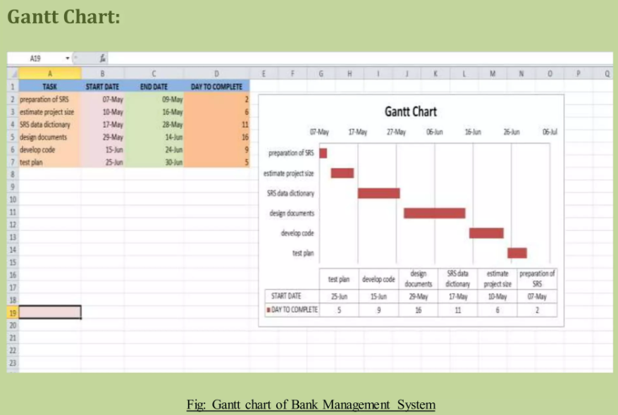

**CONCLUSION**

I have successfully designed, develop and implemented this Bank customers Management system which provides a more secured approach in managing bank customer’s information and strengthens the relationships between banks and their customers by providing the right solutions that uses a multilevel security to improve customer satisfaction. I therefore encourages other developers of similar application to think twice on how best they can improve in developing a more secured system that will meet the challenges we face today especially on the banking sector and other financial institutions.

**REFERENCES**

1. Fundamentals of database systems by (Elmasri Navathe, 2000), Website:https://archive.org/stream/FundamentalsOfDatabaseSystemselmasrinavathe# page/n51/mode/2up, Page: From 52 to more.

[2] Article: Online banking, Website: <https://en.wikipedia.org/wiki/Online_banking>

[3] Online Bank Account Management System Website: <http://www.slideshare.net>

[4] MySQL video tutorial Durgasoft online.com

[5] Veneeva, V. (2006), “E-Banking (Online Banking) and Its Role in Today's Society”, Ezine articles Java Durgasoftonline.com.